**Functional Specification**

The New UTD Activity center system is intended to support activity center with following functions

1. Speed up reservations of court for games
2. Easy access to the availability of courts
3. Ability to play with other players who are willing to share the court
4. Users of the system are Students, Alumni,
5. The System would have user interface for end users and recreational staff

**Functional Requirement**

1. **Select Game Type**

This feature enables users to select the type of sports that they are looking for and the subsequent steps will have the context of the sports selected

1. **Look up for court**

This feature enables users to have a snapshot of courts reservations per slot. The list returned is filtered based on the game selected previously. The list would have different time slots and GREEN color would mean available, BLUE would mean booked and YELLOW mean they are booked by other user but they allow other users to play with them.

This snapshot should have capability to select the GREEN slots and the timings would be populated in the form

1. **Make reservation**

This Screen would be a form which captures user inputs and provides capability to make reservation.

It should capture following

* Date. One should only be allowed to make booking as far as 2 days from current date
* Court
* Start Time – User should only be allowed to make a booking latest by 2 hrs before actual timing
* End Time
* If Equipment like Badminton racquet is needed or not.
  + We need to capture Equipment Type and Quantity needed
  + We also need to show the quantity of the equipment is available
* UTD Email ID
* Phone Number

1. **Confirmation Page**

This page would just be confirmation page assuring user that reservation is made.

User should be able to navigate to home page from this page

At the same time, a SMS should be sent to the user with the details of reservation

1. **Reservation List**

There should be a list of Upcoming reservations and past reservations.

Customer should also have capability to cancel a reservation from here. At the same time, customer should be allowed to cancel only the upcoming reservations. They should not be allowed to change anything for past reservations.

Only Staff should be able to update active reservation. Current system does not allow update of reservation from end user. They are allowed to cancel and make a new reservation.

**Data Dictionary**

Activity Centre Staff

* OnlineActivitySystem = BookANewSlotForm + CheckUpdateAndCancelReservationForm
* BookANewSlotForm = ListofSports + SlotReservationGraph + EnterNewInformationForm + SaveButton
* ListofSports = {Basket Ball|Badminton|Tennis|Racquet}
* SlotReservationGraph = {TimeSlot + {CourtAvailableYes|CourtAvailableNo|CourtAvailableToShare}}
* EnterNewInformationForm = Court + Date + Start Time + End Time + Equipment Type Needed + Equipment Qty Needed + Equipment Available + UserInformation + [ReadyToShareYes|ReadyToShareNo]
* CheckUpdateAndCancelReservationForm = ReservationInformation + AllReservations
* ReservationInformation = Court + Date + Start Time + End Time + Equipment Type Needed + Equipment Qty Needed + UserInformation + [ReadyToShareYes|ReadyToShareNo]
* AllReservations = {SurrogateRecordNumber + UserInformation + Court + Date + Start Time+ End Time + Equipment Type Needed + Equipment Qty Needed  + [ReadyToShareYes|ReadyToShareNo]}
* UserInformation = UTD Email ID + Phone Number

End User

* HomePage = ListofSport
* MakeAReservationForm = Date + SlotReservationGraph + EquipmentNeeded + Start Time + End Time + UserInformation + [CourtShareConsent + [Other User Needed]]
* SlotReservationGraph = {TimeSlot + {CourtAvailableYes|CourtAvailableNo|CourtAvailableToShare}}
* EquipmentNeeded = (Equipment Available Message) + EquipmentType + Qty Needed
* EquipmentType = [Badminton Racquet|Tennis Racquet|Shuttlecock|Basket Ball|Tennis Ball]
* ReservationList = UpcomingReservations + PastReservations
* UpcomingReservations = {ReservationCourt + ReservationDetails}
* PastReservations { ReservationCourt +ReservationDetails}
* ReservationDetails = Reservation Date + ReservationStartTime +  ReservationEndTime + ReservationStatus

**Interface design**

End user

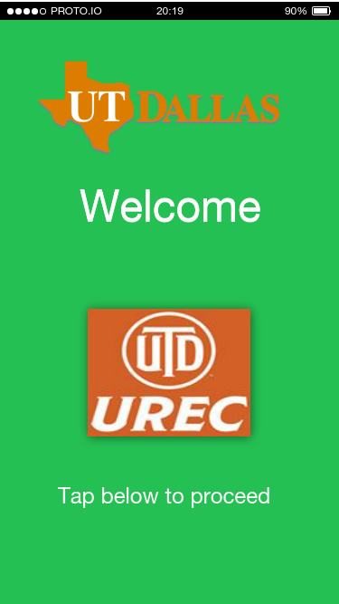 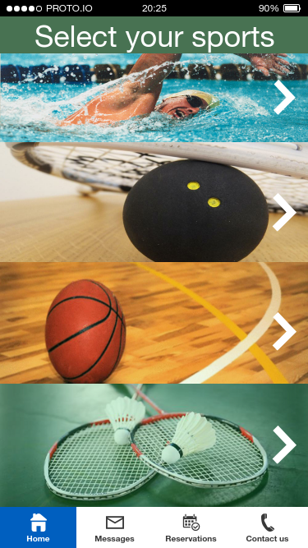 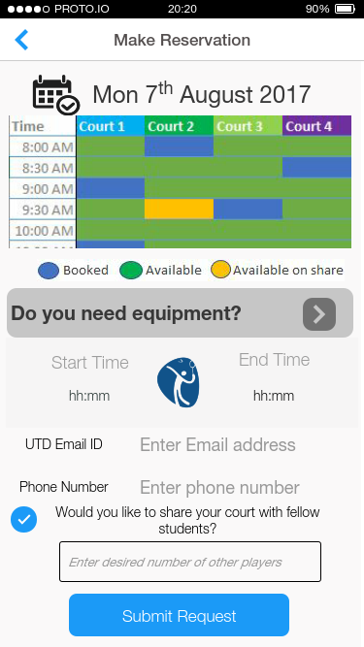

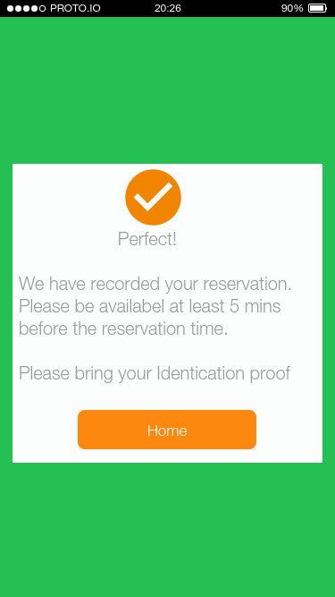 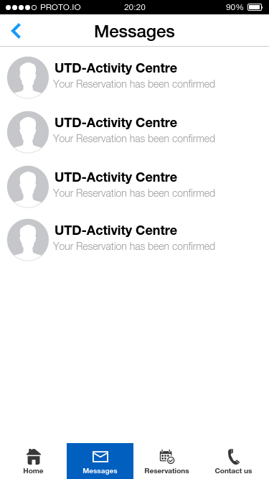 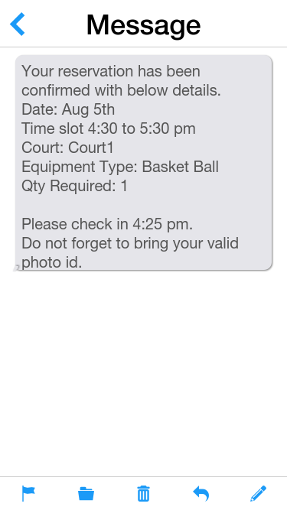

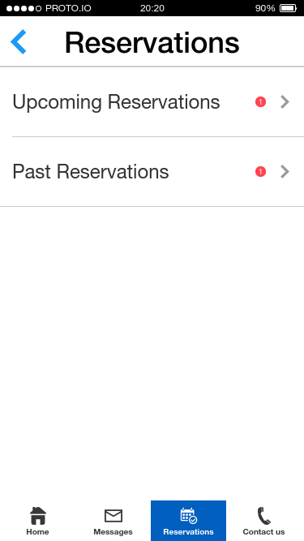 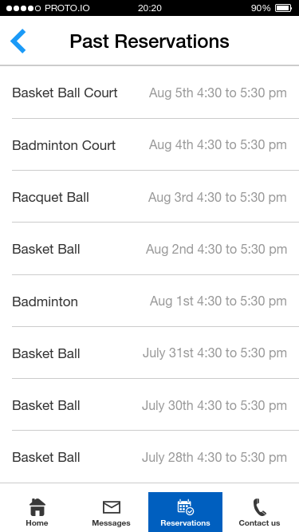 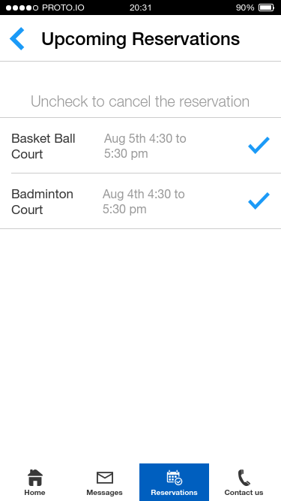

Activity center staff

